*Complete as much as you can during next 24 hours. Send your results anyway even if it not completed for 100%.*

**JavaScript**

**Elementary physics.**

1. Create an area with two rectangles.
2. Add drag and drop for rectangles. (User can move rectangle to any position at the area)
3. On rectangle intersection rectangle that dragged should emit moving of another.
4. Rectangle can’t be dragged outside of the area.

5*. (Optional) Do the same with 3 and more rectangles.

**Addition**

1. Implement function “sum”.
2. Outputs of function should be next:

|  |  |  |
| --- | --- | --- |
| 1 | sum(2)(3)() | 5 |
| 2 | sum(2)(4)(3)() | 9 |
| 3 | sum() | 0 |
| 4* (Optional) | sum(2,4)(3)() | 9 |
| 5* (Optional) | console.log(sum(2)(3)) | print> 5 |

**Alone listener**

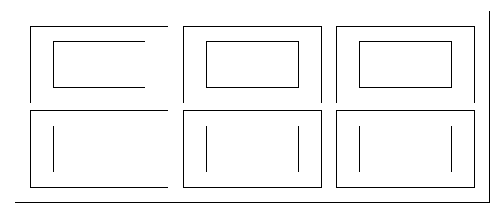

1. Create grid like at the picture above.
2. When user click on any block it should highlight.
3. Use only 1 (one) event listener.

**TypeScript**

**Fake function**

function fakeSqrt(a : number) : number {

return a;

}

1. Don’t change function **body.**
2. Function should return square root of first argument.